# **CIS 36A :: LAB 3 - Control Statements**

#### **Student Name:**

### **Task 1: Definitions & Concepts**

**Instructions:** Answer the questions below.

1. What is the difference between *for* loop and *while* loop?   
   => A for loop sets a range through which it repeats the code that is housed in it. A while loop repeats until a condition is made false.
2. When is a good time to use a ***do-while*** loop instead of a ***while*** loop?  
   => When you want to check a condition before and run while.
3. Explain the difference between using a “***break”*** and “***continue”*** in a loop?   
   => A break breaks out of the loop entirely. A continue just skips to the next iteration of the loop.

### **Task 2: Understanding Programming**

Instructions: Answer each question below. Try to understand and explain the code.   
**Do not put an IDE code screenshot.**

1. What is the difference between 5, ‘5’,”5”?  
   => 5 is an integer, ‘5’ is a char, and “5” is a string.
2. Write a ***for***statement for a loop that counts from 2000 to 100 by -4.  
   => for (int i = 2000; i >= 100; i+=4;){}
3. Is the following fragment valid? Why or why not? Assume that **sum** and **count** have been declared and initialized already.   
   for(int i = 0; i < 10; i++)   
    sum += i;  
   count = i;  
   => No because the next two lines are not enclosed by braces.
4. What does the following fragment print?  
    for(int i = 0; i < 10; i++){  
    System.out.print(i + " ");  
    if(i%2 == 0) continue;  
    System.out.println();  
    }  
   => 0 1 2 3 4 5 6 7 8 9

### **Task 3: Programming Exercises**

Instructions: Use any IDE to write and execute below exercises from the book chapter 3. Attach Snipping photos of your source code and test run of the code in the console. Make sure your code is readable.

**TRY THIS**

1. Do the TRY THIS 3-1 (Page 87), 3-2 (Page 99), and 3-3 (Page 110).   
   Share only the screenshot of the code and the test run of 3-3.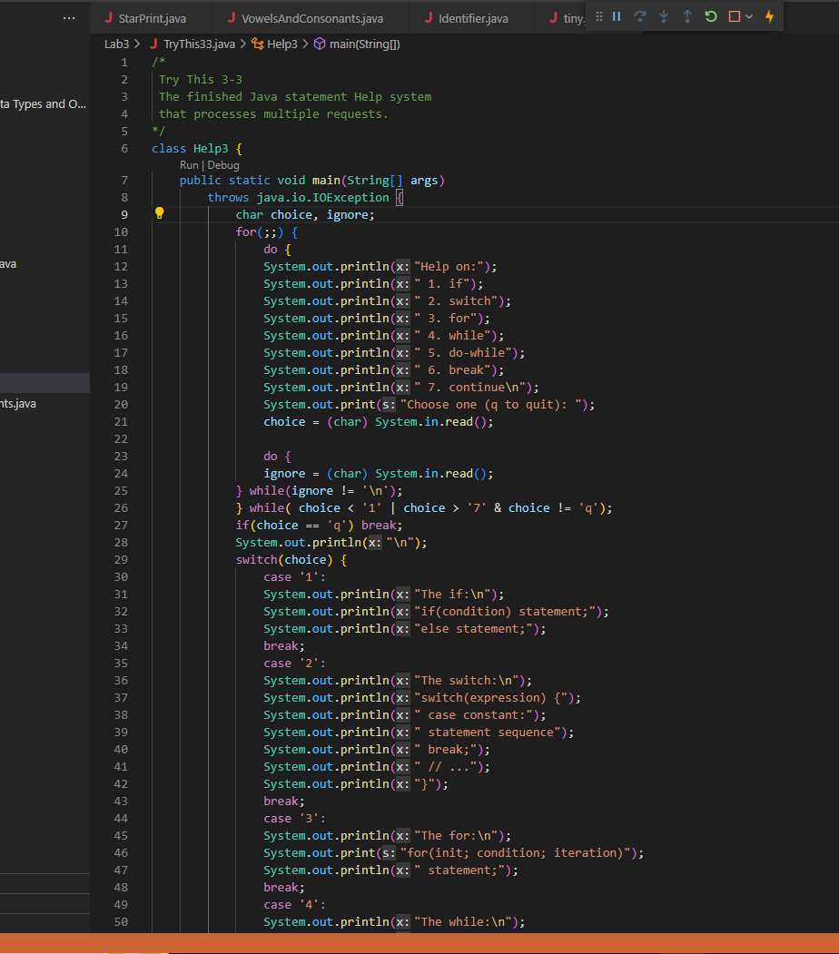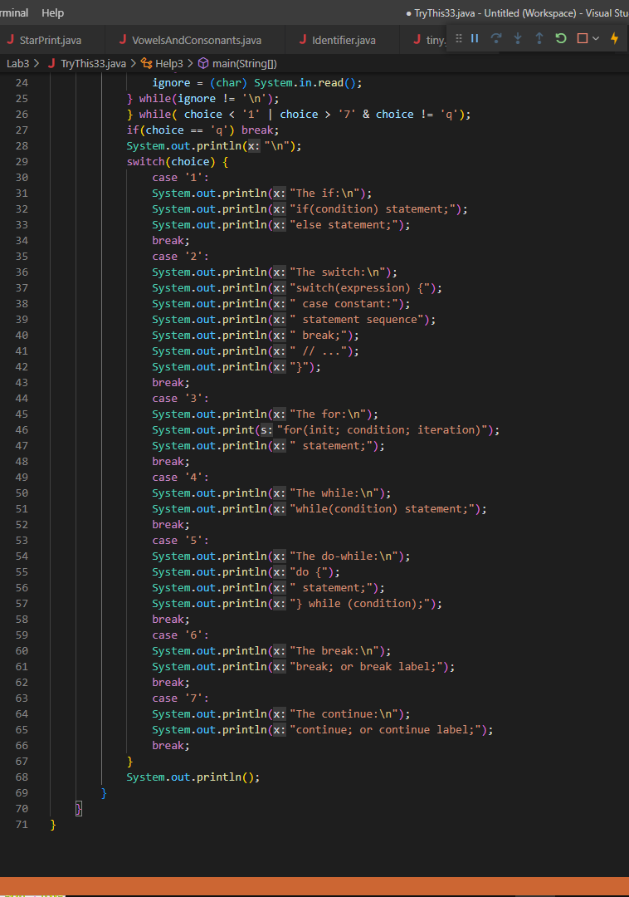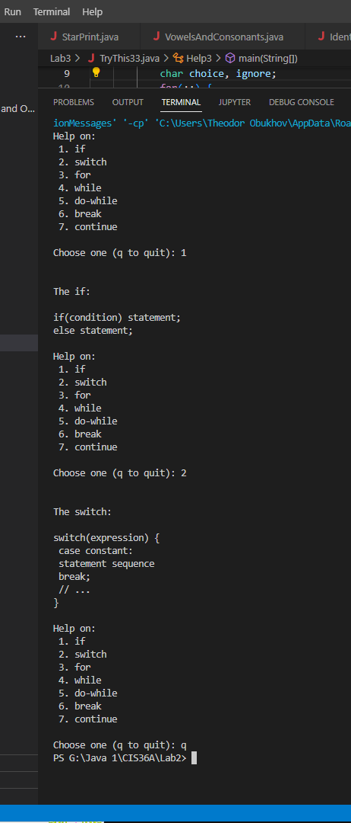

**Chapter Exercises: Do the following chapter exercises.**

* Exercise 1: Write a program that reads characters from the keyboard until a ***'Q'***is received. Have the program count the number of **'A'**s. Report the total at the end of the program. 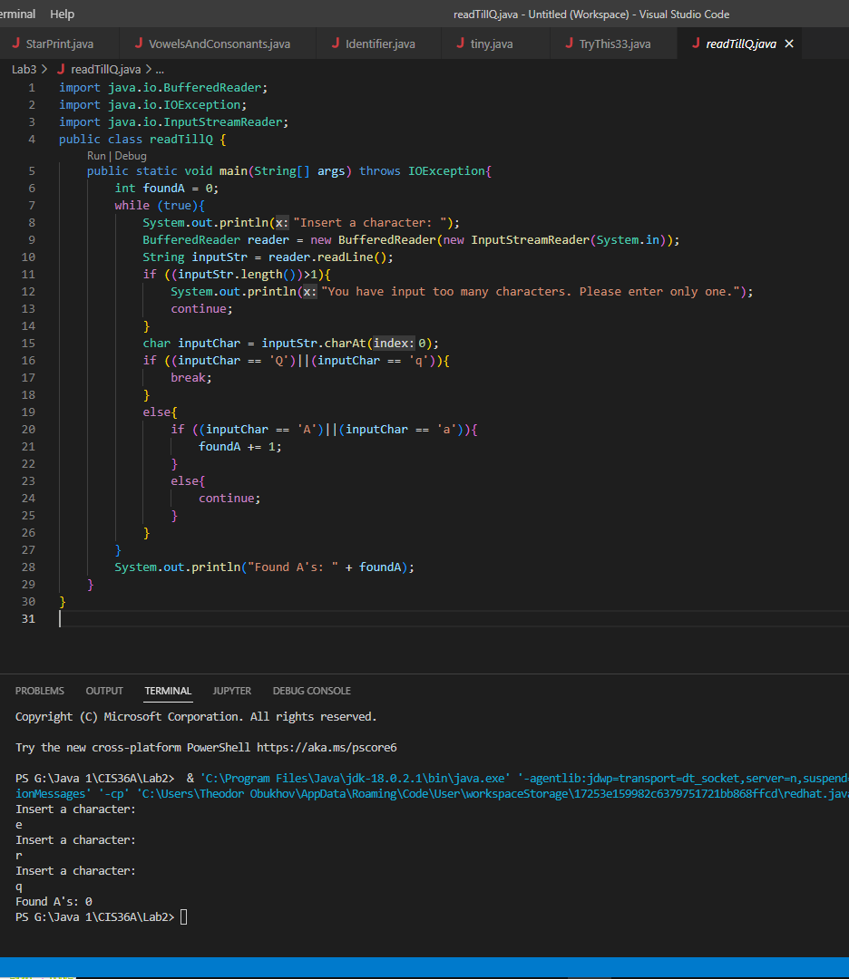
* Exercise 16: Write a program that uses a loop to print the powers of 3 from 30 up to and including 39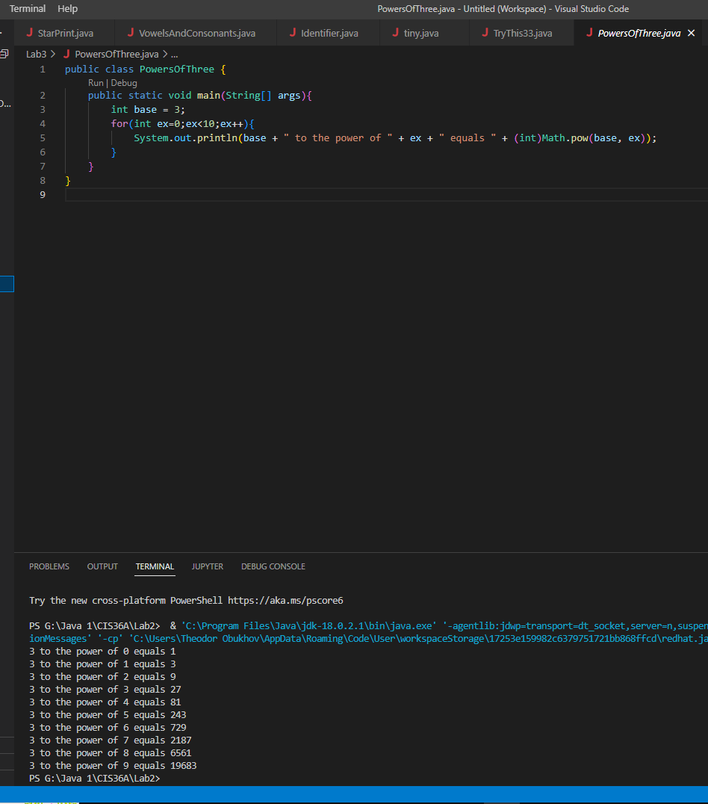
* Exercise 17: Write a program that uses a loop to print a list of 100 numbers consisting of alternating 1's and -1's, starting with 1.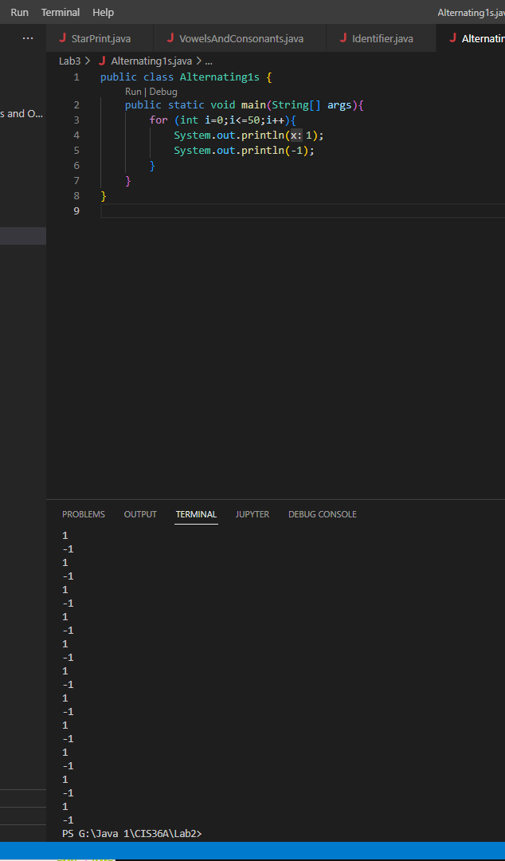
* **Exercise 18:** The class FindFac discussed in this chapter prints the factors of all numbers from 1 to 100. Modify this class so that, instead of stopping at 100, it keeps going until it finds a number with exactly nine factors.
* Exercise 20: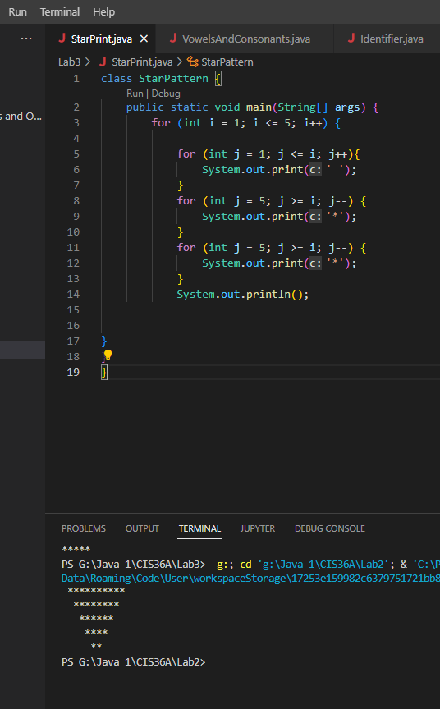
* Exercise 23: If you divide 1 by 2, you get 0.5. If you divide it again by 2, you get 0.25. Write a program that calculates and outputs the number of times you have to divide 1 by 2 to get a value less than one 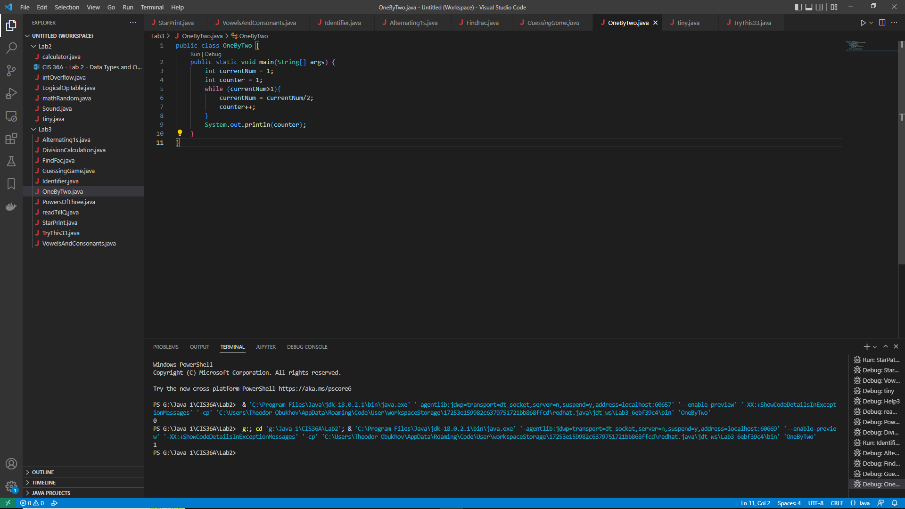ten-thousandth (0.0001)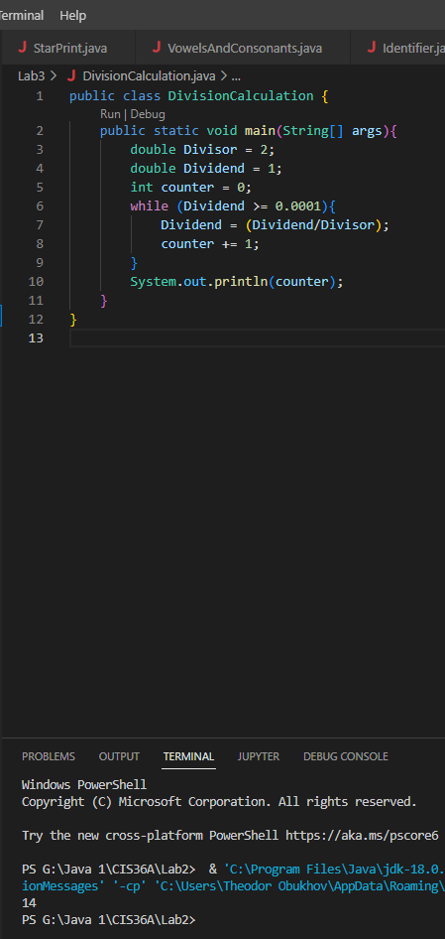
* Exercise 19: 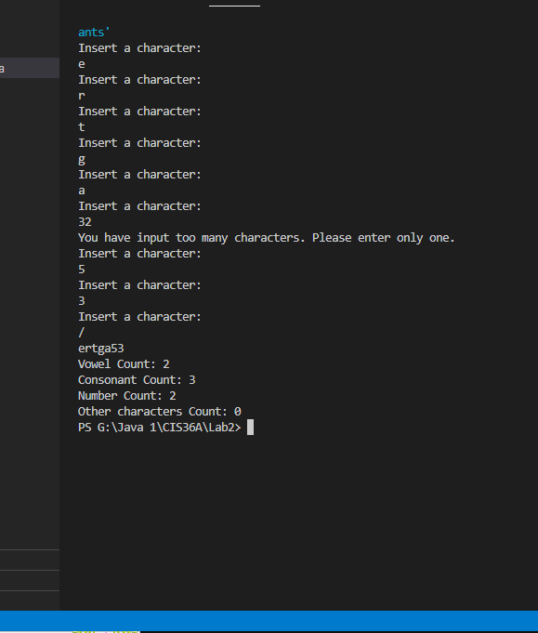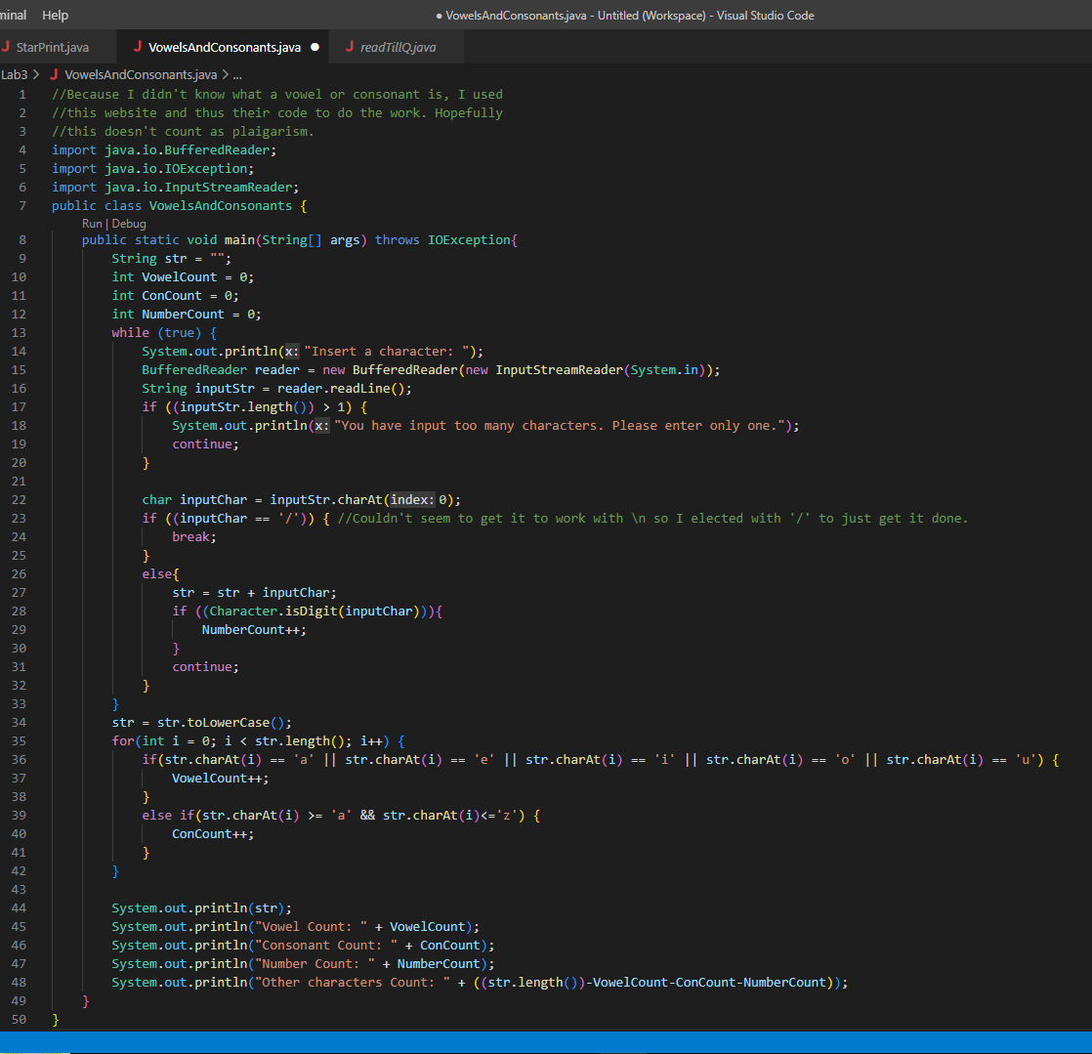
* Exercise 21: 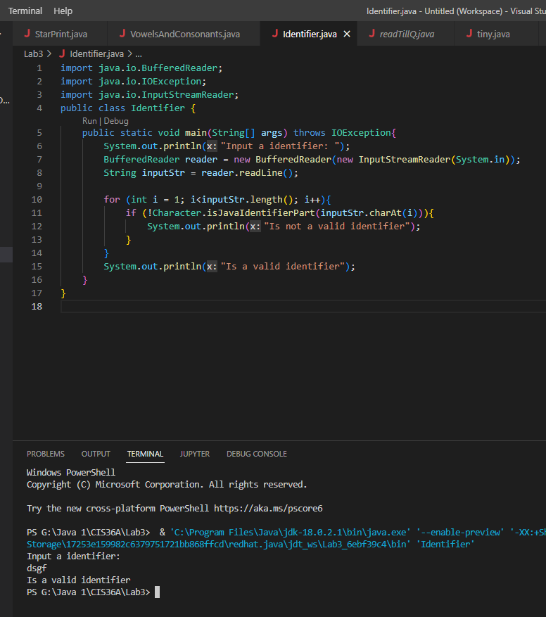

**Task 4: Programming Application**

**Guessing game:** Create a java class called GuessingGame. Your program should pick a random integer between 1 and 100. Then, it should ask the user to guess the number and should give feedback whether the number is greater than or less than the original number. You should create a loop, either ask the user for a number of times or until the user guessed the number correctly. The loop should end when the user guesses the number.

**Challenge 1:** Give points to the users based on how fast they guess the number and negative points if it takes more than a certain amount of guesses

**Challenge 2:** Ask the users whether they want to play the game again or you can allow them to play repeatedly. Users should be able to exit the game whenever they want.

